**Project Design Phase-II**

**Data Flow Diagram & User Stories**

|  |  |
| --- | --- |
| Date | 03 October 2022 |
| Team ID | PNT2022TMID35841 |
| Project Name | Project – Data flow diagrams and user stories |
| Maximum Marks | 4 Marks |

**Data Flow Diagram:**

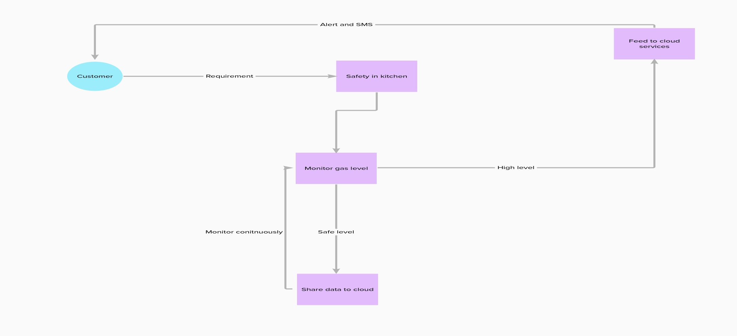

**User Stories**

| **User Type** | **Functional Requirement (Epic)** | **User Story Number** | **User Story / Task** | **Acceptance criteria** | **Priority** | **Release** |
| --- | --- | --- | --- | --- | --- | --- |
| Customer (Mobile user) | Registration | USN-1 | As a user, I can register for the application by entering my phone number or email | I can access my alerts | High | Sprint-1 |
| Customer (Web user) | Registration | USN-2 | As a user, I will receive confirmation email/OTP once I have registered for the application | I can receive confirmation email & click confirm | High | Sprint-1 |
|  | Login | USN-1 | As a user, I can login to my account using my registered email id or mobile number | I can view data | High | Sprint-2 |
| Customer (Data types) | Data viewing | USN-1 | As a user, I will be able to view my more recent alerts and monitoring status | I can check the level of gas in the room | Medium | Sprint-1 |
|  |  | USN-2 | As a user, I will get the alert if gas levels increase | SMS notification received | High | Sprint-2 |
| Customer Care Executive | Action | USN-1 | As a user, I can view the problems in network or whichever stage of the framework to solve the problem of the customer | Receive complaint | Medium | Sprint-2 |
| Administrator | Storage | USN-1 | As the administrator, I make sure data of the customers are stored safely and securely | Data stored in cloud database | High | Sprint-2 |